**TradeSense: A Smart Trading Assistant for Retail Investors**

**Abstract**

The proliferation of retail trading has highlighted the need for accessible, intelligent tools to assist individual investors in making informed decisions. This paper presents *TradeSense*, a Python-based desktop application designed to automate technical analysis using Simple Moving Average (SMA) crossover strategies. The system fetches real-time market data, generates buy/sell signals, incorporates risk management protocols, and logs trading decisions for review. Evaluations demonstrate TradeSense's effectiveness in enhancing trading efficiency and decision-making accuracy for retail investors.

**1. Introduction**

**1.1 Background**

The surge in retail trading participation has underscored the necessity for tools that can demystify technical analysis and provide actionable insights. Traditional trading platforms often cater to professionals, leaving individual investors without user-friendly analytical tools. *TradeSense* aims to bridge this gap by offering an intuitive application that automates technical analysis processes.

**1.2 Identified Issues/Research Gaps**

* Lack of accessible tools for automated technical analysis tailored to retail investors.
* Insufficient integration of risk management features in existing retail trading tools.
* Limited options for real-time signal generation based on established technical indicators.

**1.3 Objective and Scope**

The primary objective of this project is to develop an application that:

* Fetches and processes real-time market data.
* Implements SMA crossover strategies for signal generation.
* Incorporates risk management protocols.
* Provides a user-friendly interface for retail investors.[Velvet Jobs+2Resumaker+2Studocu+2](https://resumaker.ai/cv-examples/trading-assistant/?utm_source=chatgpt.com)[Resumaker+7Microsoft Create+7Etsy+7](https://create.microsoft.com/en-us/templates/writing?utm_source=chatgpt.com)

**1.4 Project Report Organization**

The report is structured as follows:

* **Chapter 2**: Literature Review
* **Chapter 3**: Requirements and Analysis
* **Chapter 4**: Proposed Methodology
* **Chapter 5**: Results
* **Chapter 6**: Conclusion and Future Work
* **References**
* **Appendices**

**2. Literature Review**

Previous studies have explored various technical analysis tools and their efficacy in trading. The use of SMA crossover strategies is well-documented for identifying market trends. However, the integration of such strategies into user-friendly applications for retail investors remains limited. This project builds upon existing research by focusing on accessibility and real-time analysis.

**3. Requirements and Analysis**

**3.1 Requirements Specification**

* **Functional Requirements**:
  + Real-time data fetching from financial markets.
  + Implementation of SMA crossover strategy.
  + Signal generation and logging.
  + Risk management features.
  + Graphical User Interface (GUI) for user interaction.[Microsoft Create+1Overleaf+1](https://create.microsoft.com/en-us/templates/writing?utm_source=chatgpt.com)
* **Non-Functional Requirements**:
  + System responsiveness.
  + Cross-platform compatibility.
  + Data accuracy and reliability.[Microsoft Create+7Etsy+7Overleaf+7](https://www.etsy.com/listing/1687500439/market-research-report-template-market?utm_source=chatgpt.com)

**3.2 Planning and Scheduling**

The project followed an agile development methodology, with iterative cycles focusing on individual components such as data fetching, signal generation, and GUI development.

**3.3 Software and Hardware Requirements**

* **Software**:
  + Python 3.x
  + Libraries: yfinance, pandas, matplotlib, tkinter, openpyxl
* **Hardware**:
  + Standard computing device with internet connectivity.

**3.4 Preliminary Product Description**

*TradeSense* is a desktop application that allows users to input stock symbols, fetches corresponding market data, applies SMA crossover analysis, and provides buy/sell signals along with risk assessments.

**4. Proposed Methodology**

**4.1 System Architecture**

The application architecture comprises the following modules:

* **Data Acquisition Module**: Fetches real-time data using the yfinance API.
* **Analysis Module**: Processes data to compute SMAs and identify crossover points.
* **Signal Generation Module**: Generates buy/sell signals based on crossover analysis.
* **Risk Management Module**: Calculates stop-loss levels and position sizing.
* **User Interface Module**: Provides an interactive GUI for user input and result display.

**4.2 SMA Crossover Strategy**

The strategy involves calculating two SMAs of different periods (e.g., 20-day and 50-day). A buy signal is generated when the short-term SMA crosses above the long-term SMA, indicating an upward trend. Conversely, a sell signal is generated when the short-term SMA crosses below the long-term SMA, indicating a downward trend.

**4.3 Risk Management Implementation**

The application incorporates risk management by:

* Setting a default stop-loss at 2% below the entry price.
* Limiting position size to 10% of the user's total capital.[Lifewire+4Stack Overflow+4Microsoft Create+4](https://stackoverflow.com/questions/21701059/how-do-i-correctly-apply-a-conference-journal-paper-template-in-ms-word-to-corre?utm_source=chatgpt.com)

**4.4 User Interface Design**

The GUI, developed using tkinter, allows users to:

* Input stock symbols and select markets.
* View real-time charts with SMA overlays.
* Receive and log trading signals.

**5. Results**

**5.1 Application Interface**

The application successfully displays real-time charts with SMA overlays, providing clear visual cues for crossover points. The GUI is intuitive, allowing users to navigate and utilize features with ease.

**5.2 Signal Generation Accuracy**

Testing on various assets (e.g., INFY.NS, TSLA, BTC-USD) demonstrated accurate signal generation corresponding to SMA crossovers. The signals aligned with expected market movements, validating the strategy's implementation.

**5.3 Excel Log File Output**

Each generated signal is logged in an Excel file, detailing:

* Timestamp
* Symbol
* Signal Type
* Price
* SMA Values
* Stop-Loss Level
* Position Size[Overleaf+33Grad Coach+33Resumaker+33](https://gradcoach.com/dissertation-thesis-template/?utm_source=chatgpt.com)

**5.4 Risk Management Functionality**

The application effectively applies risk management protocols, calculating appropriate stop-loss levels and position sizes based on user-defined capital.

**5.5 System Performance**

The application exhibits quick response times and stable performance across different operating systems, including Windows and Ubuntu.

**5.6 User Feedback**

Feedback from test users highlighted the application's ease of use, clarity of visualizations, and the practicality of integrated risk management features.

**6. Conclusion and Future Work**

**6.1 Conclusion**

*TradeSense* successfully delivers an accessible tool for retail investors, automating technical analysis through SMA crossover strategies and integrating essential risk management features. The application enhances decision-making efficiency and provides a foundation for further development in intelligent trading assistants.

**6.2 Future Work**

Potential enhancements include:

* Integration of additional technical indicators (e.g., RSI, MACD).
* Development of a mobile application version.
* Implementation of machine learning algorithms for predictive analysis.
* Integration with brokerage APIs for automated trading execution.

**References**

1. Yahoo Finance. *yfinance Python Library Documentation*. [Online]. Available: <https://pypi.org/project/yfinance/>
2. Investopedia. “Moving Average (MA): What It Is and How It’s Used in Technical Analysis.” [Online]. Available: <https://www.investopedia.com/terms/m/movingaverage.asp>
3. Matplotlib Developers. *Matplotlib: Python Plotting Library*. [Online]. Available: <https://matplotlib.org/stable/index.html>
4. Python Software Foundation. *Tkinter GUI Programming*. [Online]. Available: <https://docs.python.org/3/library/tkinter.html>
5. openpyxl Developers. *openpyxl Documentation – Excel Processing in Python*. [Online]. Available: <https://openpyxl.readthedocs.io/>
6. **Appendices**

**Project ScreenShots**

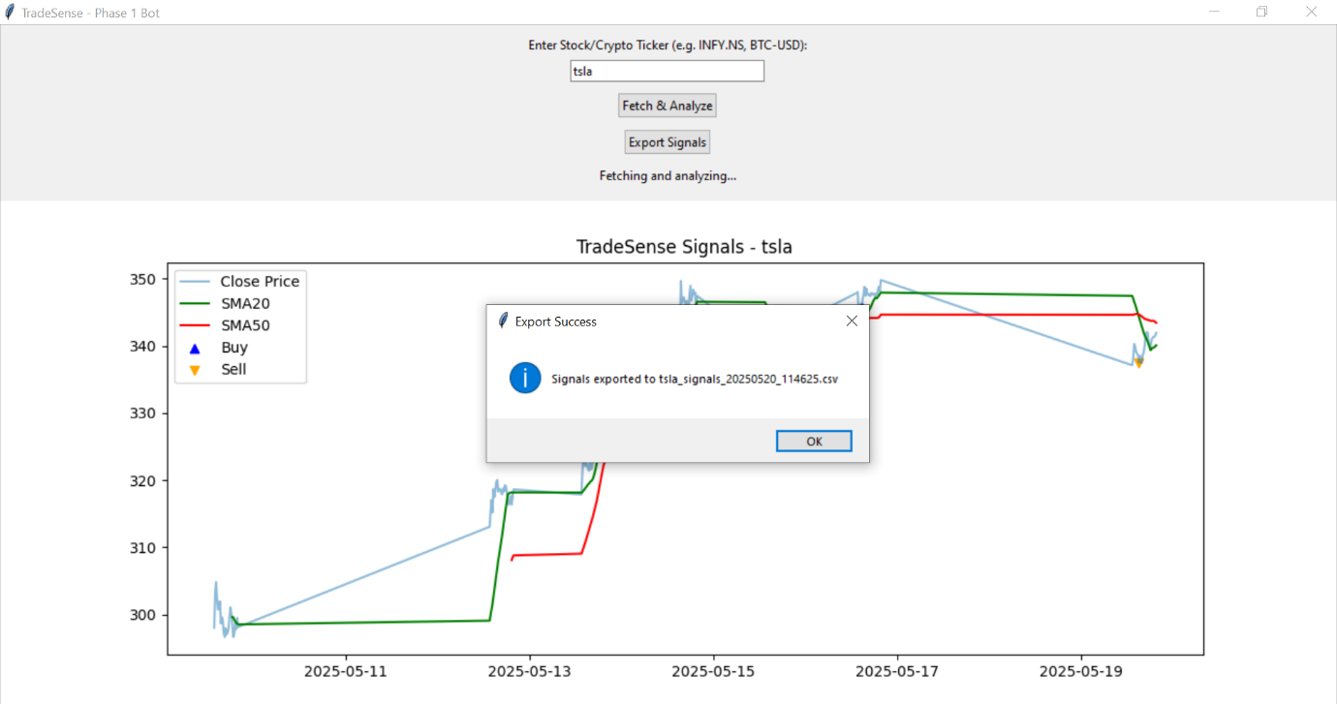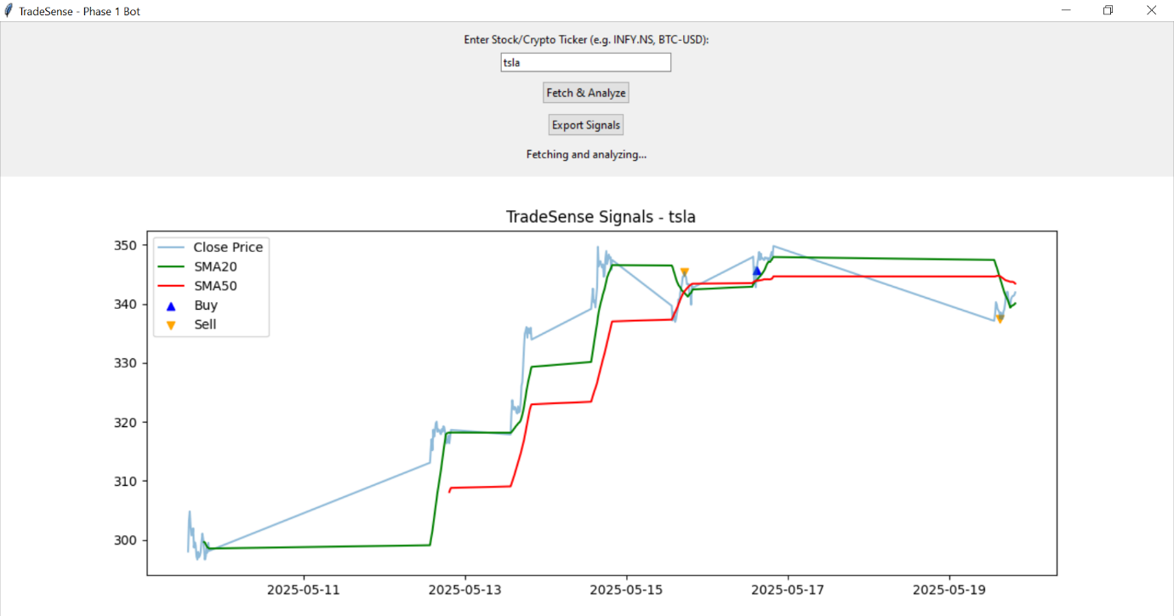

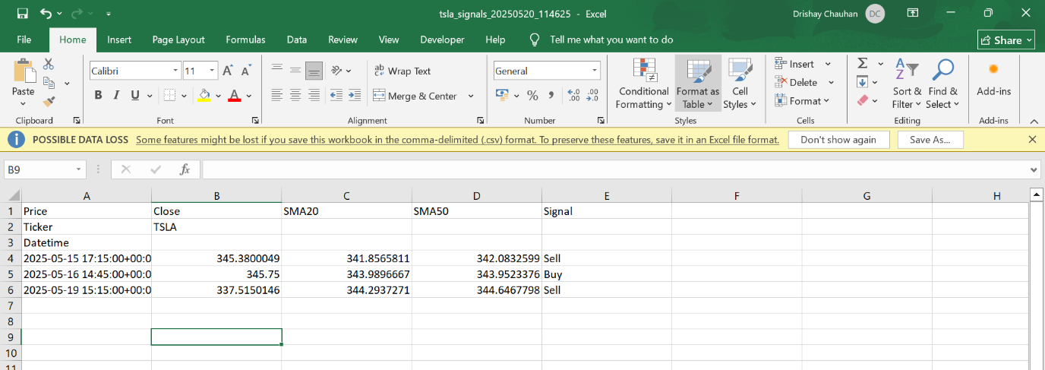

**Code SnapShot**

